
NOTICE OF LIABILITY (NOL) INSTRUCTIONS
Round One

WHAT THIS IS:
You are sending a NOTICE OF LIABILITY REGARDING COVID-19 MEASURES to hold 7 people (Respondents/Libelees) liable and accountable. (You can send to more than 7 Respondents/Libelees, or less, it is up to you to remove a Respondent or add one or more). Please note: The NOL process takes serious commitment. There are more steps after this—this is not a one-time mailing, and postage expenses should be expected. Make sure to keep the original for yourself as you will be filing a UCC-1 Financing statement at a later step.

FIRST STEP:
If the NOL isn’t specific to your state already, it needs to be adapted to your state: In other words, if a State Constitution is quoted, you need to switch it out with the same or similar from your own State Constitution, and anything cited about the state in particular, including the codes found on page 2. The first 5 Respondents/Libelees) need to be switched out to your state actors (Robert R. Redfield and Anthony Fauci remain). Read the NOL carefully and change out the STATE specifics to your own STATE’s specifics.

Some research will be necessary.

Autographing:
You will date the top of page one of your NOL for the date you will be mailing it. You and your witnesses will autograph your NOL on or around page 13 and you will autograph again on the last page. Place your seal and the seal of your witnesses (red ink thumbprint over the last letter of your surname and witnesses surnames respectively). Please use your appellation First-Middle: Last in upper and lower case letters.

ALWAYS use a BLUE, Purple or Gold INK PEN to sign your original documents. You will KEEP all your originals of the NOL and the Bills of Lading (BOL) and ONLY mail copies (black & white is fine).

WITNESSES:
* The TWO witnesses can be family or friends of age and sound mind.
* You do not have to use the same witnesses for each round, but it is recommended.
* The best witnesses are those you can easily meet with and who support your intentions.
* No Notary should be used for this non-statutory process—witnesses only.
* Witnesses should use an address where personal mail is received, and it needs to be the same address2
for each step.
* The 2 witnesses are designated RECIPIENTS for correspondence from respondents/libelees
pertaining to this matter.

* When the witnesses sign, they are agreeing to have witnessed you actually mail these documents, so
either use people who completely trust you or have your witnesses accompany you to the post office through the mailing process, so that they see you actually mail the documents they witnessed.

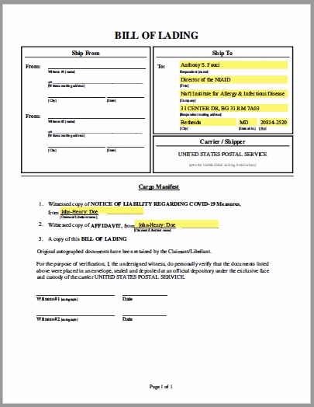
BILL OF LADING (BOL)

A BOL is a receipt obtained by the shipper of goods from the carrier (trucking company, railroad, ship or air freighter) for shipment to a particular buyer. It is a contract protecting the shipper by guaranteeing payment and satisfies the carrier that the recipient has proof of the right to the goods. The bill of lading is then sent to the buyer by the shipper upon payment for the goods, and is thus proof that the recipient is entitled to the goods when received. Thus, if there is no bill of lading, there is no delivery.

A BOL needs to be created for each Respondent/Libelee for each individual mailing.

1. Your Respondent/Libelee’s name and address goes in the “Ship To” section (it is OK to use the zip code for the Respondents/Libelees)

2. Your Witnesses fill in the Ship From sections, or you can fill it in for them, and DO NOT use zip codes here. The Witnesses must sign and date the BOL for the day you mail it. NOTE: Your Witness #1 will be the one whose name and address will go on the Green Return Receipt Cards with the mailing (if you decide to use them), and is the one who will be receiving those back for you.

3. Print YOUR name on lines 1 and 2 under “Cargo Manifest”.

4. Place the Tracking number sticker strip from your Certified Mail slips under the Carrier/Shipper section (you will do this when you prepare your mailings).

5. If there is yellow highlighting on your BOL, please remove it.

IN CASE OF ERROR AFTER DOCUMENT HAS BEEN SIGNED BY CLAIMANT/LIBELLANT & WITNESSES: If any corrections need to be made prior to mailing, do a single strikethrough, write the correction, and initial. Witnesses need not initial in this case.

IN CASE OF ERROR AFTER DOCUMENT HAS BEEN MAILED: If any corrections need to be made after mailing, you will need to send a NOTICE OF CORRECTION, which specifies any correction(s) which need to be made. This can be included in the following round, or on its own.

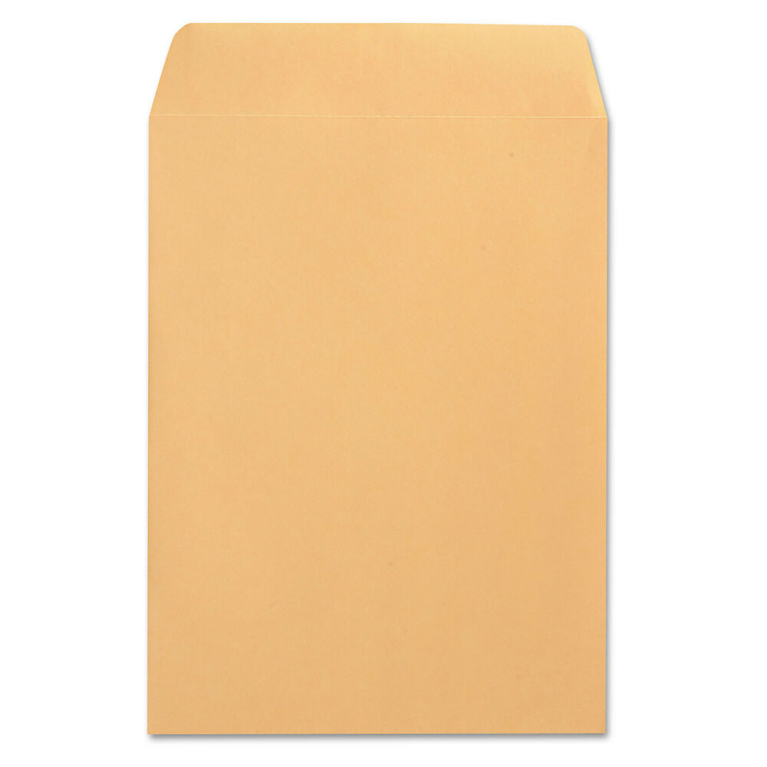
Value and Consideration:

To place value into the contract use a postal stamp placed in the upper right hand corner under the date shipped (2 cent or greater) and discharge the value of the stamp by having the stamp bopped by a Post Office worker or you can autograph across it with your First-Middle: Last from the upper left side of the stamp diagonally to the lower right side of the stamp. In Blue, Purple or Gold ink pen and place your red thumbprint seal over the last letter of your surname (not necessary if bopped by the post office worker).

MAILING:

Use 9” X 12” envelopes, one for each Respondent/Libelee. (Do not fold your documents inside a smaller envelope.)

1. You or your Witness #1 can print his/her address on the top left corner, but do not use a zip code. If you want to use a zip code, put brackets around it: [98123]
Sample Witness “From” Address: Witness’s Name
c/o Mailing Address City, State

2. Be sure the thin white Certified Mail Tracking number sticker strip is placed on the BOL under the Carrier/Shipper section, and write the Tracking Number on the Green Return Receipt card (if you decide to use these) where it says “2. Article Number” at the bottom.

3. Put a COPY of each BOL on top of the stapled COPY of the NOL and put them in their envelopes. DO NOT staple or clip the BOL to the NOL. (Keep your original NOL paperclipped.)

4. BE SURE to double-check that the names, addresses and tracking #’s all match up. – for each of the document packages. Make sure that each Bill of Lading matches its envelope address label and the Certified Mail Receipt tracking # – and matches one of the names on the front of your NOL.

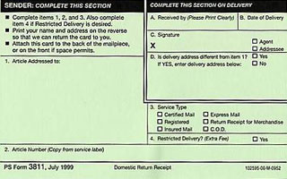
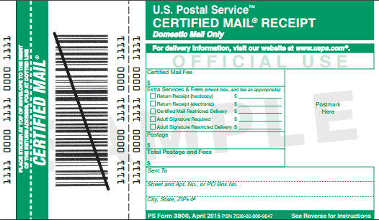

5. For the Return Receipt Green postcard: [NOTE: You do not have to use the Green Return Receipt postcard. If you choose not to, once your envelopes are mailed and 3-6 days have gone by, you can check tracking to see if it has been delivered. If it has, you print out that page as evidence of delivery and collect them together.]
To use the Green Postcard:
a. Matching a Green Postcard up with each envelope, write the following on it:
i. In Section 1: write Respondent's/Libelee’s name & mailing address
ii. In Section 2: write the tracking# in the "Article Number" section of each Green Postcard.
iii. In Section 3: check "Certified Mail"
iv. On the back, write the return address for your 1st Witness (who is listed as
Shipper on your BOL).

b. Remove the adhesive strips & attach the completed Green Postcard to the back of
the envelope, or the front if space permits, making CERTAIN that the Tracking number you wrote on the Green Postcard matches the tracking number sticker on the BOL inside.

6. Seal all documents in the envelope and give to the post office clerk for payment and processing of receipts. Be sure to keep your payment receipts and the stamped address portion of the Certified Mail Receipts.

7. In 3-6 days you can easily track your numbers on the USPS website. Also, check in with your Witness #1 to see if he or she is receiving back the Green Return Receipt postcards. When you have them all back, keep them safe.

KEEP ORGANIZED:

Create a file for this process, and store your original signed documents in it, along with your Certified Mail receipts and payment receipts. Mark this section “Step One COVID NOL” or something like that. These originals are VERY important to keep safe.

YOUR NOL gives the Respondents/Libelees ten (10) days to respond. When they don’t (or if they do respond but not appropriately), you go on to the next step: Notice of Fault and Opportunity to Cure Liability.

Thank you for doing your part to actively estoppel these government actors from their crimes against the people by issuing despotic unconstitutional orders outside of their delegated authority! We the people must hold them accountable for their immoral actions.

